Setting up Raspberry Pi on a newly bought Pi

Flashing (for a brand new Pi)
If newly bought, the Pi is just empty, so you need to download the OS to start using it:
- Get an adapter that can connect the SD card (typically an empty one) to the desired device
- Download the Raspberry Pi Imager OS (official website)
- The screen should appear then Select the device and the image model
  - The image model could be either from an SD card that was stored on your computer or the following OS provided
  - 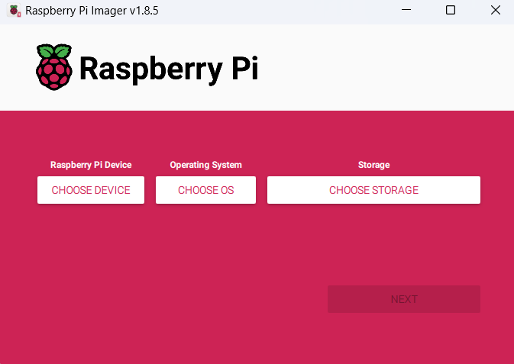
- Once you have selected the options, press next and wait for the imager to finish writing
- Once completed, remove the SD card and put it into the desired Raspberry Pi then plug in the power supply
- The Pi should be on and would need to be hooked up to a monitor (needs a dongle for HDMI), mouse and keyboard
- Pi should start booting up and display on the screen
- YAY, you successfully started up a Pi now go be a menace

Imagining and Writing
Similar to copying the information from a previous SD (imaging), which can either be pasted on a
new or used pi (writing)

Imagining (either from a previous or new Pi)
- Reading (for Windows)
  - Take the SD card from a current pi and connect it to your laptop
  - Download the Win32DiskImager
  - The following page should show up
    - (To confirm if the SD is in, under “device” it should show random symbols)
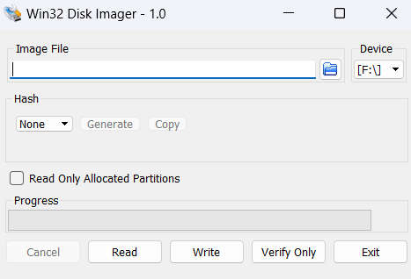
  - Select the folder button in the “image file” box, create a file, and save
  - Return to the page and select “Read”
    - Estimated time should take within minutes or less than an hour
- *if hour >1 select cancel, issue I’m not sure of (ask Sebastian)

Writing (Putting information from a previous SD onto a new SD card)
- Follow the “Imaging” direction to have the copy of the previous SD card file that you want to have write on a new SD
- Take the new SD you want to write over and plug it into the computer with the file
- Open Win32DiskImager
  - In the “Image File” click the folder icon and select the Image of the previous SD
  - Select “Write” to start copying over the information to the new SD
- Once the file is complete you have identical SD cards and you can use it how you see fit, Yay!

Software Configuration for Remote Access

On-board Pi Information
- Connect the Pi to a monitor, keyboard, and mouse
- Connect the Pi to the RedRover network (more steps involved, but I forgot, sorry -Ethan)
- After connecting successfully to the network, the IP address will pop up briefly
- Otherwise, to access the IP address:
  - Open the terminal
  - Type ifconfig
  - You should see a terminal output with three sections; under the last section, labelled wlan0, write down the IP address following inet, which should have the form xxx.xxx.xxx.xxx
- In the terminal, type sudo raspi-config
- Navigate to “Interface Options”, then “VNC”, and press “Yes” to enable VNC.

On Your Computer: Windows
- On your computer now, be sure you have RealVNC installed
- RealVNC might prompt you to make an account; simply continue to the account creation, then press cancel
- In the top bar, enter the IP address previously saved
- When prompted, use the current Raspberry Pi credentials to sign into the Pi
NOTE: Although multiple users can connect to the Pi remotely, they are all functionally controlling the same computer; thus, operations performed by one user will be reflected across all connected devices.
NOTE: The IP address is also liable to change after turning off and on again, so if connection fails, double check you have the right IP address

